**MEDIA RELEASE- 16th December 2019**

**Regional participants selected for**

**Screenworks 2020 Career Pathway Programs**

*top row:* Samuel Rodwell, Isabel Darling, Hiromi Matsuoka, *middle row:* Michelle Patkowski, Jess Wheatley, *bottom row*: Rebecca O’Brien, Jo Coby, Robyn Marais

Seven creatives from across regional NSW and one from the Pilbara in Western Australia have been selected to participate in Screenworks 2020 Career Pathways Program, which have been funded by Screen NSW and Screenwest. The selected early-career regional writers, directors and producers will each receive support to progress their screen industry careers from Screenworks, Screen Producers Australia, the Australian Directors Guild and a number of top Australian production companies through placements, mentoring, industry introductions and professional development.

Selected for the ***2020 Regional Producer Elevator Program*** are Northern Rivers NSW based Jo Coby, South Coast NSW based Hiromi Matsuoka and from the Pilbara in Western Australian is Robyn Marais.

Screenworks has partnered with Jungle Entertainment, Matchbox Pictures and Fremantle for this program so each of the participants will get to spend at least five days at one of these production companies to shadow and observe a professional working producer who will also give them career and project advice.

Each of the selected participants will also receive: entry to the 2020 Screenworks Business of Producing Seminar in Ballina in March 2020; registration at the 2020 Screen Forever Conference on the Gold Coast in November 2020 where they will be able to participate in selected emerging producer sessions through Screen Producers Australia’s (SPA) Ones to Watch program; each recipient will receive support from SPA in finding a mentor to work with them in the lead up to Screen Forever; plus $3,500 to go toward their professional/career development. This program is supported by Screen NSW, Screenwest and Screen Producers Australia.

Selected for the ***2020 Director Pathways Program*** are Northern Rivers NSW based Rebecca O'Brien and South Coast NSW based Isabel Darling. Rebecca and Isabel will each receive $3,500 to support the implementation of their bespoke career plans to advance their careers as Screen directors. This program is supported by Screen NSW and the Australian Directors Guild

Selected for the **2020 Inside the Writers Room** program are Michelle Patkowski from South West NSW who will observe a writers room at Easy Tiger, Jess Wheatley from the Northern Rivers of NSW who will head to Every Cloud Productions and Samuel Rodwell from Central Western NSW who will go to Fremantle Australia. Each of these early-career writers will have the opportunity to observe a professional writers room in progress over a number of days. This program is supported by Screen NSW and the three production companies – Fremantle Australia, Easy Tiger and Every Cloud Productions.

“We were blown away by the calibre of applicants for our 2020 Career Pathway Programs”, explained Screenworks CEO Ken Crouch. “It clearly demonstrates the extensive talent living in regional areas and the value of these programs in creating opportunities to connect to the industry. We also really value the support the partner production companies and industry guilds provide to help us bring these opportunities to regional creatives.”

For more information on the participants who were selected for Screenworks Career Pathways Program visit [www.screenworks.com.au](http://www.screenworks.com.au)

Screenworks’ *Career Pathway Programs* are funded by Screen NSW and supported by Screenwest, Fremantle, Jungle Entertainment, Matchbox Pictures, Screen Producers Australia, Every Cloud Productions, Easy Tiger and the Australian Directors Guild.

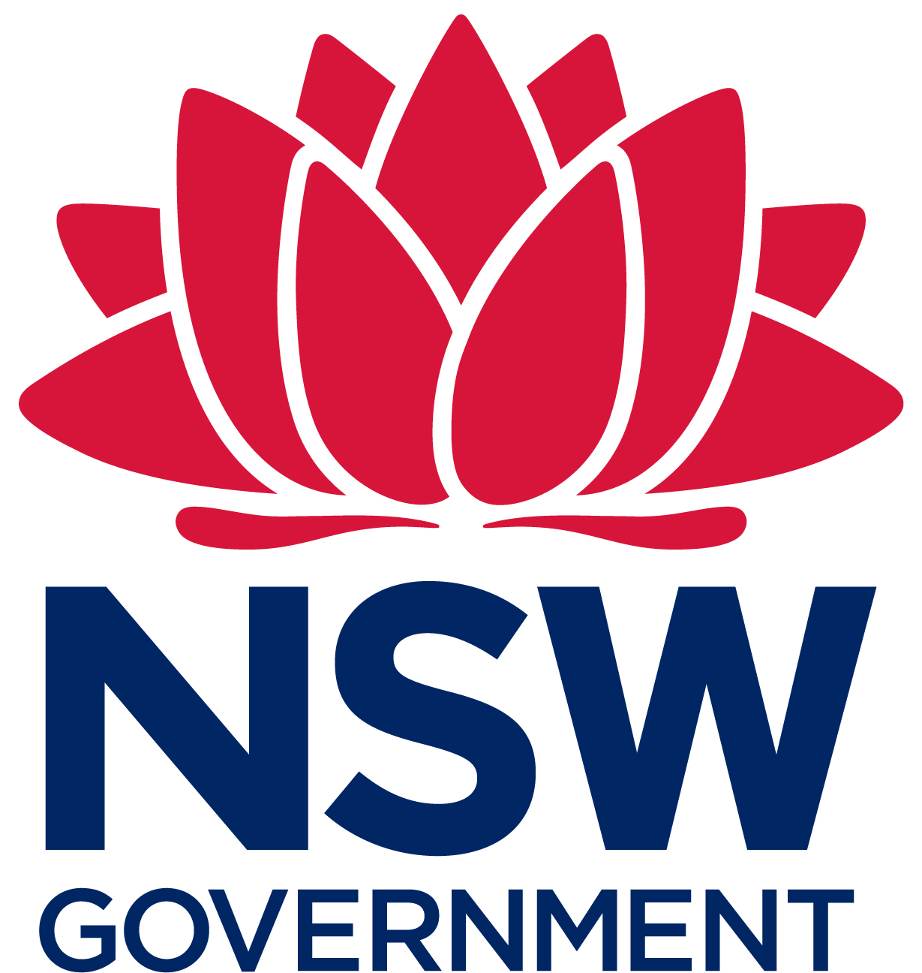

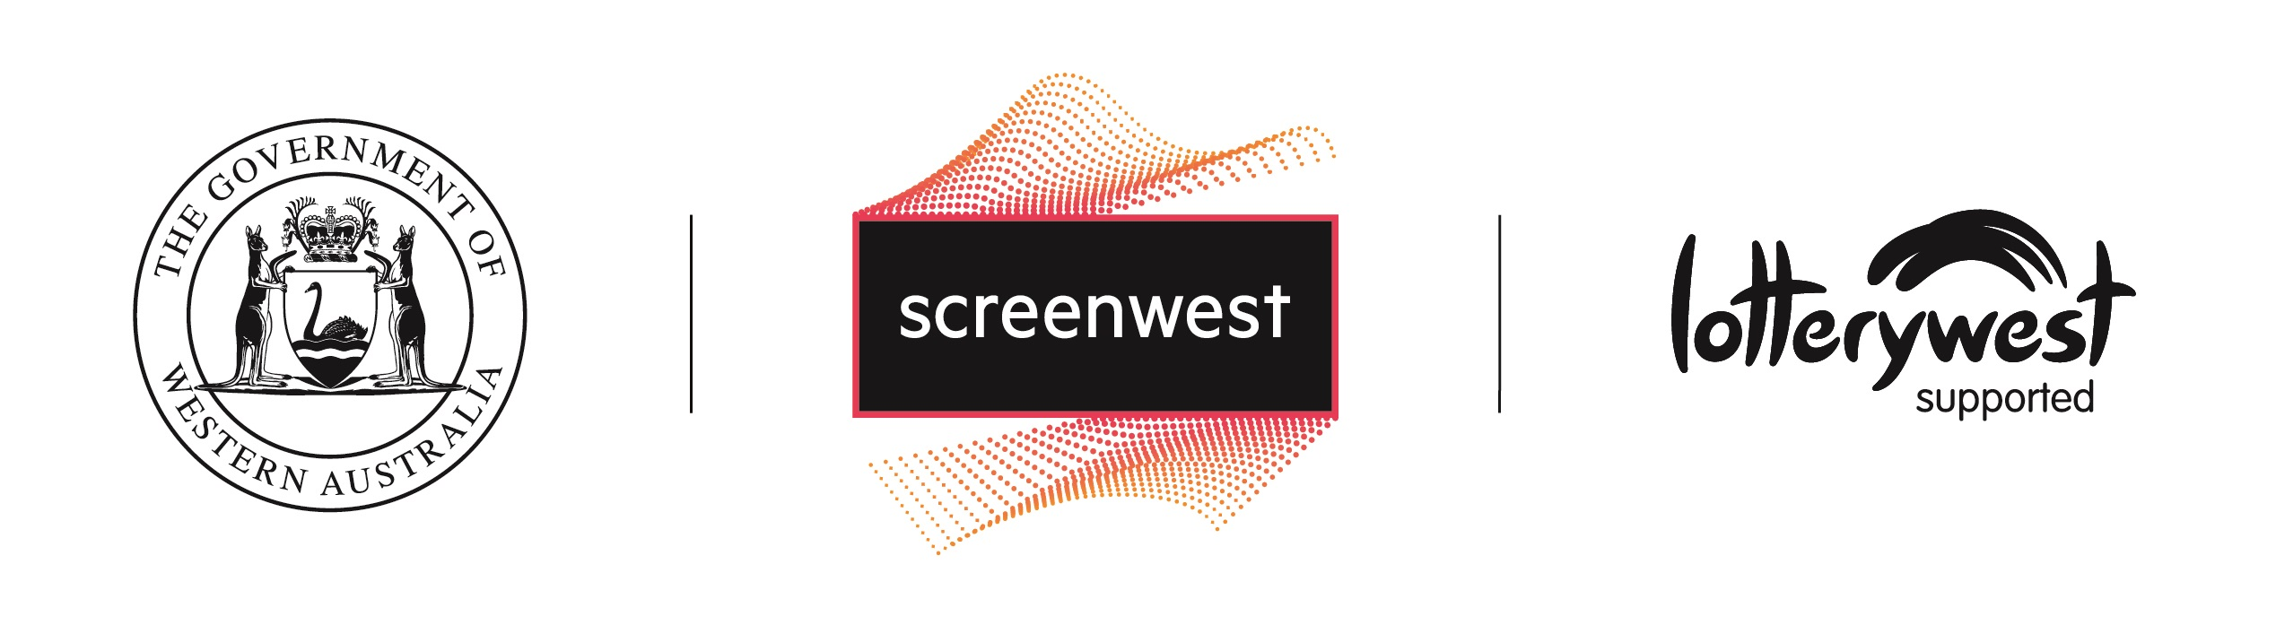

 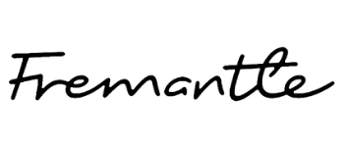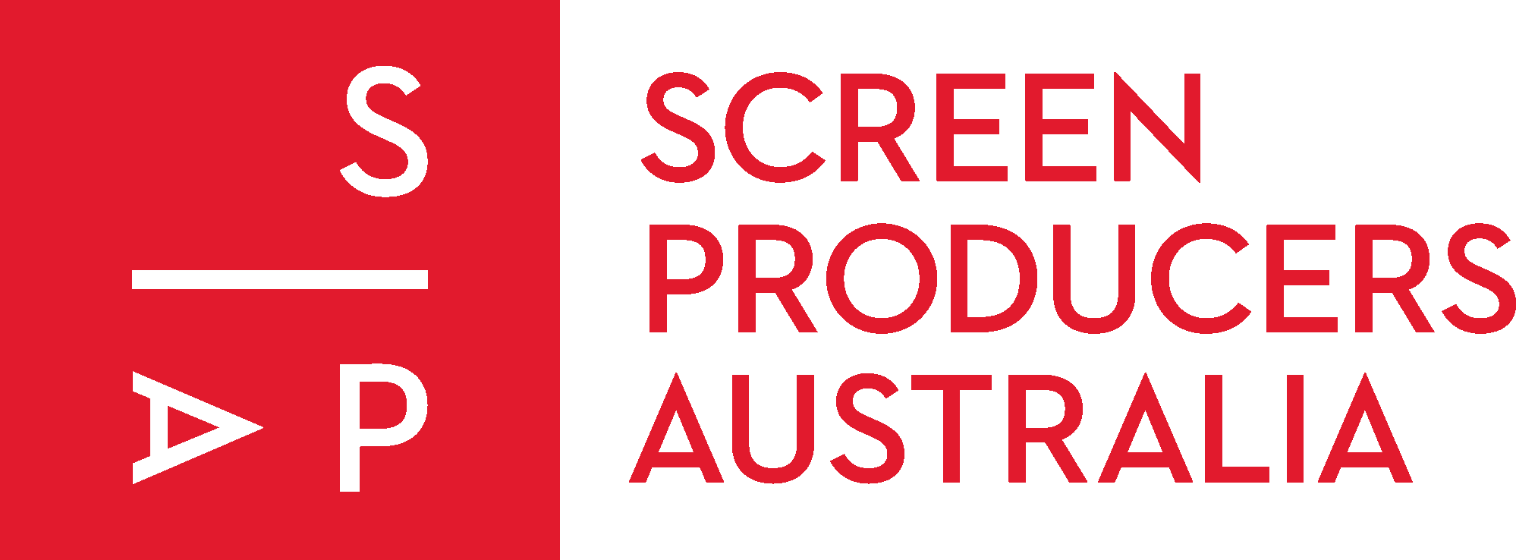

   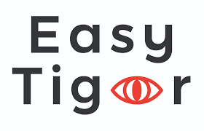

For more information contact Lisa O’Meara Screenworks Programs and Operations Manager

02 6681 1188 events@screenworks .com.au

Website: [www.screenworks.com.au](http://www.screenworks.com.au)

Facebook: [www.facebook.com/ScreenworksAU/](http://www.facebook.com/ScreenworksAU/)

Twitter: [www.twitter.com/Screenworks_Aus](http://www.twitter.com/Screenworks_Aus)

**About Screenworks**

Screenworks is a registered charity that provides support, leadership and vision for the regional screen industries in Australia.

The principal objective of Screenworks is to promote and advance the screen industry in regional, rural and remote Australia, with a focus on the industry cluster in the Northern Rivers region of NSW.

Our principal activities provide screen-related development and networking opportunities, programs and initiatives specifically designed to support people living in regional, rural and remote Australia.

We are a home-grown not-for-profit, membership based association managed by a board of volunteer directors that provide industry, management and screen industry knowledge and experience.

**About Selected Participants**

**Regional Producer Elevator Program**

**Hiromi Matsuoka** is based on the Far South Coast of NSW and has worked extensively on global advertising campaigns, TVCs, and TV series, shooting all over the world. She is now keen to produce both narrative and nonfiction Australian regional stories and bring them to the screen.

Hiromi is a founding member of not-for-profit associations Screen Illawarra and Far South Film, and apart from on-going commercial projects is developing a slate of films to be shot in the SE Region of NSW that will tell the stories of a diverse and changing community.

**Jo Coby** is an emerging Screen Producer and writer who has been creating content since she was very young. Jo has several original series concepts, and scripts on her slate, and is interested in pursuing a career focussing on bringing new and diverse stories to Australia and the wider world. Of note, Jo has an original series based on her life and that of her brother in early development with a Sydney-based production company, and has recently gained solid first-hand experience in development rooms (for her own project and in workshops she was selected for), in concept and script development, casting, and working alongside an experienced production team and notable industry professionals.

**Director Pathways Program**

**Isabel Darling** is a director living in Batemans Bay, NSW. Since her studies in Film & TV production in Melbourne in 2002, Isabel has worked as a director and cinematographer on large-scale tourism projects, short films and documentaries.

Her short documentary *Corey the Warrior* was selected by numerous festivals around the world, including the Melbourne Documentary Film Festival where it was nominated for Best Australian Short Documentary in 2017. It also screened on ABC iview, SBS TV, Foxtel and was selected as part of the Virgin inflight program for 2018.

Isabel is currently in production on the observational feature documentary *In For the Ride* - which follows a 5th generation carnival family across Australia, and has been filmed over a 4 year period. Isabel is also in pre-production on a short narrative film which will be filmed in early 2020 on the NSW South Coast.

Isabel is passionate about regional people and their stories, with a particular focus on sub-cultures.

**Rebecca O’Brien** is an award-winning filmmaker, a graduate of AFTRS, an AACTA nominee, recipient of Screen Australia’s talent escalator program and most recently the recipient of the Screenworks Directors Pathway Program

As a teen growing up in Christchurch, New Zealand, Rebecca bought a video camera and started documenting her world. Now, a little older, her successful career to date includes working for ABC TV, NITV, Southern Star and Universal creating a wide variety of scripted and unscripted projects. These include the award-winning, Screen NSW funded short film, *The Great Dark*; which has received over 1.3 million views on Youtube,  producing Play Schools historic 50th-anniversary episode, as well as shadowing Michael Rymer as he created the final episodes of the Emmy-award winning drama *Battlestar* *Galactica* (SyFy). Rebecca has just finished directing part of the Aquarius Films / Netflix production *The Unlisted (*2019), which is currently screening on ABC iview and Netflix.

**Inside the Writers Room**

**Jess C Wheatley** is a Screenwriter Director with a passion for world building and concept development. After growing up in the hinterland behind Byron Bay, Jess completed a Design Degree in Brisbane and a Motion Design Degree in Sydney — where she focused on Production and Pre Production. She has recently completed a Masters of Screenwriting at VCA. With her background in graphic design, illustration, art department, character and set design and a history of creative writing, she finds herself drawn to diverse stories and enjoys every moment of it. Jess freelances as a pitch document designer and storyboardist while continuing to hone her screenwriting projects

**Michelle Patkowski, Yass, NSW.**  Michelle Patkowski is a self-taught, regional internationally award-winning Screenwriter, who manages Complex Trauma disorder. Her drive and determination to tell stories with the intention of impacting the lives of others is at the core of her work. Michelle’s writing garnered her the attention of Producers and Agents from across the pond. Her multi award-winning film Script *The Debt* is in development with Thorny Devil Productions in L.A. Michelle is naturally drawn to Drama but is also experienced in writing Action/Adventure and has developed and taken the natural progression into TV writing, where her talent and discipline for her craft can really be explored.

**Samuel Rodwell** is an award-winning Australian writer, director and producer.

Rodwell received his tertiary education at Charles Sturt University, taking a wide interest in exploring diverse subject matters from astronomy, cosmology, film, literature and philosophy before graduating with his bachelor's degree in Communication.

Best known for directing the short films, *Monkey* (2015) and the forthcoming Inferno (2020), where Rodwell has gone onto to be recognised for his quality over quantity approach in filmmaking that has solidified his film career thus far.

Rodwell is an accomplished television commercial director, specialising in crafting large-scale, cinematic and action-packed commercials for a plethora of NSW Government emergency services to education agencies.

In-between directing commercials and short films, Rodwell constantly develops his original slate of feature films and television projects, focusing on crafting sophisticated written narratives, exploring intellectual themes and diverse genres intended for both Australian and international audiences.